Main Project entitled

HOME AUTOMATION USING MOBILE

Submitted in partial fulfilment of academic requirements for the award of the degree of Bachelor of Engineering (Computer Science and Engineering)

By

SAI KIRAN TADURI 2451-12-733-028

P.V.K. ROHITH 2451-12-733-045

AMITH SAI UPPU 2451-12-733-044



Department of Computer Science and Engineering

M.V.S.R. ENGINEERING COLLEGE

(Affiliated to Osmania University & Recognized by AICTE) Nadergul, Saroor Nagar Mandal, Hyderabad – 501 510
2015-16.

Department of Computer Science and Engineering

M.V.S.R. ENGINEERING COLLEGE
(Sponsored by Matrusri Education Society, Estd. 1980) (Affiliated to Osmania University & Recognized by AICTE)
Nadergul, Saroor Nagar Mandal, Hyderabad – 501 510



CERTIFICATE
This is to certify that the project entitled “HOME AUTOMATION USING MOBILE”, is being submitted by SAI KIRAN TADURI (2451-12-733-028), P.V.K. ROHITH (2451-12-733-045) and AMITH SAI UPPU (2451-12-733-044) in partial fulfilment of academic requirements for the award of the degree of BACHELOR OF ENGINEERING in COMPUTER SCIENCE AND ENGINEERING from MVSR Engineering College, affiliated to OSMANIA UNIVERSITY, is a record of bonafide work carried out by him under the guidance and supervision of the faculty (CSED). The results embodied in this project report have not been submitted to any other University or Institute for the award of any degree or diploma to the best of my knowledge and belief.
Guide Project Coordinator
SRIDHAR SRIDHAR
Assistant/Associate Professor, Assistant Professor
Dept. of CSE Dept. of CSE MVSR Engineering College MVSR Engineering College

ACKNOWLEDGMENT
I take this opportunity to express my profound and sincere gratitude to all those who helped us in carrying out this project successfully.
At the very outset, I am thankful to our principal Sri Dr.V. Chandra Sekhar and Sri J.Prasanna Kumar, Professor and Head, Department of Computer Science and Engineering, MVSR Engineering College, Hyderabad for their consent to do the project work as a part of our B.E Degree (CSE). We thank them for their valuable suggestions and advice throughout our stay at the college, during our project work.
I would like to thank our Internal Project Guide Mr. V.SRIDHAR, Assistant Professor, Department of Computer Science and Engineering, MVSR Engineering College for his/her useful suggestions, guidance and encouragement.
We thank the teaching and non-teaching staff of CSE for extending their support.

Finally we are thankful to our parents for their cooperation and support throughout all endeavours in our life.

SAI KIRAN TADURI ( 2451-12-733-028)
P.V.K. ROHITH (2451-12-733-045)
AMITH SAI UPPU (2451-12-733-044)

1.INTRODUCTION

Home Automation, refers to the automatic and electronic control of the household features, activity and appliances. Various control systems are utilized in this residential extension of building automation. Home automation gives you access to control the home appliances from a mobile devices from anywhere in this world.
Mobile phone is a revolutionary invention of the century. It was primarily designed for making and receiving calls & text messages, but it has become the whole world after the Smart phone comes into the picture. In this project we are building a home automation system, where one can control the home appliances, using the simple GSM based phone, just by sending SMS through this phone. In this project, no Smart phone is needed, just the old GSM phone will work to switch ON and OFF any home electronic appliances, from anywhere.
Some devices that can be controlled are lights,fans,Air conditioner ,TV etc. From Home security perspective, this also includes alarm system and all of the doors , windows , locks etc.For implementing this we need Arduino Board,GSM module,Mobile phone,Relay module and connecting wires.When we send a message to the SIM which is placed in GSM module, this module forwards the message to the arduino board through serial communication.Now on receiving this message arduino board will control the electronic appliances connected to it by making the output pins as low or high. In this way we can control any electronic appliances through mobile.

In this project, Arduino is used for controlling whole the process. Here we have used GSM wireless communication for controlling home appliances. We used some AT commands for making GSM module to enter in to the text mode. After receiving given commands by Arduino through GSM, Arduino will send signal(make output pin high or low) to relays, to switch ON or OFF the home appliances using a relay driver.

1.1 Motivation
As there is eventual growth in the field of technology, the standard of living of people is also increasing gradually. With the IoT being touted as the "next big thing" in the field of embedded systems, we must realize that an efficient and reliable home automation system will be a key part of the IoT enabled world. We aim to create an easy-to-use home automation system which can be easily integrated with other IoT devices. To make their living better we are developing a system called Home Automation using Mobile . The beauty of a home automation system is that it is highly scalable, flexible and it's capabilities are limited only by our imagination. With the revolution in IoT just around the corner, this is the right time for widespread adoption of such a system.
Home automation has been something of a science fiction fantasy for decades. Never before it has been as technically feasible as it is today. The past five years alone has seen pervasive computing become a reality, with many homes now overrun with smart phones, tablet computers, laptops, web-enabled television sets, and home computers. The time is ripe to make the home automation fantasy come true. Leading worldwide companies are spending billions of dollars to transform it from possibility to reality.
Through developing a flexible home automation system which can be easily setup, maintained and programmed by the end user the need for expensive system installers and pricey customisation and maintenance costs can be substantially reduced. By lowering costs, and offering a system which can easily be extended over time, home automation becomes an affordable and realistic option for many households.

1.2 Existing System
A remotely accessible environment is an environment in which each appliance can be remotely accessed and controlled using software as an interface, which includes an Android application and a Web application. There are various techniques for developing such system. Such remotely accessible systems are already available in the market, but have a number of drawbacks as well.
1.2.1 Bluetooth Based Home Automation
Bluetooth technology is secured and low cost. It makes use of an Arduino Bluetooth board. An interactive python program is used in the cell phone to provide the user interface. The I/O ports of the Bluetooth board and relays are used for interfacing with the devices which are to be controlled. The Bluetooth is password protected to ensure that the system is secure and not misused by any intruders. The Bluetooth has a range of 10 to 100. meters, 2.4 GHz bandwidth and 3Mbps speed. There is a diagnostic system that can detect problems in the circuitry. A feedback system will report status of devices after every signal toggle. The main drawback with respect to Bluetooth is that it takes a long time to discover and access devices in its vicinity. It does not provide energy conservation tips. Real time access cannot be achieved. Anywhere access to the devices cannot be achieved. Access is limited to within the Bluetooth range.
Bluetooth technology is used to control home appliances . The client is a PC that is connected via USB to the Bluetooth module, sensor circuit and a pulse width modulation circuit. Sensors and actuators are used to control the circuit. The Bluetooth module that is connected to it will allow it to receive various commands via Bluetooth. Bluetooth devices can scan and detect other devices easily. It might also be possible to check whether devices are working properly or not. The system also has an illumination sensor that can turn on lights when external light is dull and a temperature sensor. This system also suffers from the drawback of the range of Bluetooth being around 10 meters only. This system has the advantage of being able to fit onto an existing system. There is also low cost involved in this system.

1.2.2 Phone Based Home Automation
There are some systems that are described as an enabling system that can be used to provide a common framework for home Automation. It provides a system for a smart home that includes facilities such as a system controller, house wiring and a common interface. This will enable using the existing system for home automation. A hardware based remote controller for power point control has been described . The function of this remote controller is to control the power supplied to devices at a remote location. The system uses the telephone line for transmitting the commands. The controller is a logic system built entirely of hardware. It eliminates the cost incurred with microcontrollers. It uses a DTMF transceiver which is interfaced with a solid state relay to control the power supply. It could also be implemented experimentally with infra red signals and AC power line carrier technology.
A home automation system makes use of the dual tone multi frequency (DTMF) used in telephone lines . The system uses the standard public-switched telephone lines. There are three components in the system. The first is the DTMF receiver and ring detector. The second part is the IO interface unit. The third part is the PC which does the online operations. The PC detects the ringing of the line and then authenticates the user. After this the user will be allowed to use the keypad tones to control the devices as required. It suffers from the drawback that the number of appliances is limited by the number of keys in the keypad. An ordinary phone usually has only 12 keys.

1.2.3 ZigBee Based Home Automation
The ZigBee wireless communication technology can be applied for home automation. The system uses voice recognition and PIC microcontroller for this purpose. The voice commands are taken from a mic. They are compared with a voice store and processed. The PIC microcontroller then transmits the commands through ZigBee to the receiver. The receiver unit has another PIC microcontroller that can process the command. It uses relays to control the respective appliances. This system has the drawback that ZigBee is a low range communication medium. So remote access is hindered from faraway locations. Also, the voice recognition module could become unwieldy. This system has the added feature of integrating a smoke detector to the system. When smoke is sensed, it sends a message to the user’s built-in mobile number.

1.2.4 Wireless Control Systems
Systems using wireless communication can be made by linking up stand alone appliances that are present at home or in office and integrating to form a co operating network. A combination of various technologies like Bluetooth and Wi-Fi are used to integrate the system. The universal Plug and play capability is used to provide a transparent network of devices to the user. The system makes use of the Open Service Gateway Interface (OSGI). The appliances are connected via different networking technologies. The user application layer makes use of web browsers, pocket PC application and a central console. Speech based commands can also be used for controlling the appliances. Advanced features such as device discovery and device connection are provided. The entire system is implemented in a Linux platform. The system also has the ability to add intelligent control modules. These control modules are capable of capturing the knowledge and recognizing the patterns. The universal plug and play system uses many standard protocols for interoperability. The main advantage of the system is its interoperability. Another advantage is the dynamic discovery of the service. It also has the ability for sharing of service. The system proposed uses an Arduino board along with Wi-Fi communication technology . It also has the option of another automated mode where there are temperature and light sensors which can be set to control the appliances depending on the conditions. The system uses an Android smart phone to communicate with a home PC those servers as a server. The PC is connected to and controls the Arduino board. The GUI is designed using MATLAB. The mobile phone can communicate with the PC through Internet. Internet access is through Wi-Fi. However, this extension is not implemented in the system. The system has the advantage of remote access through the phone. The drawback is that the PC needs to be left on all the time. Also it depends on Wi-Fi for internet access which is not reliable and not widely available.

1.2.5 Mixed Type
Home automation is achieved with a combination of GSM, Bluetooth and ZigBee technologies. The user interfacing is done through an Android application. This application takes user voice input and maps it to a set of textual commands. These commands are sent through SMS to another phone at home. This in turn transfers the commands through Bluetooth to a PIC controller which is a remote unit. This unit will then send the commands to a ZigBee transceiver. The transceiver transfers these commands through ZigBee to the main controller. This controller interprets the commands and performs the required operations. It also sends back current status of the system through ZigBee. This system is usable and can offer remote access. However, the system can become expensive due the use of multiple controllers and technologies.

1.3 Proposed System
This project is designed for controlling the house hold appliances from any remote place in the world using a GSM enabled handset. Our project makes use of GSM module, Arduino Board i.e Microcontroller whose function is to control the electronic appliances.GSM module is responsible for establishing a secured connection and then receiving the SMS sent by user through mobile phone. Once the module receives SMS, it is forwarded to the arduino board through the serial communication i.e the cross connection between the Tx and Rx pins of both the modules. Now, the arduino board will store this message in its buffer. Using Arduino IDE we will develop a code which will use some predefined functions for checking the availability of data in the buffer and for reading the contents of the buffer. Once the data is read, it is compared to the command using the string comparison function. Based on the result of the comparison required action is taken by arduino board by making the output pin as high or low.
We used two rectifiers, one for GSM module and another for arduino board.GSM module requires 12V power and arduino board needs 5V.

1.4 Challenges
There are several challenges and considerations involved while developing a home automation system, many of which are determined by user needs.
Type of Interface: The most basic and crucial requirement in a home automation system, the interface is the basic communication protocol and hardware combination used for sending and receiving messages between devices and the user. One have many options for executing communication between devices, the user, and the overall system, depending upon the system, range, size of house, ease of use, etc. If a user wants to control the home appliances through the Internet, the designer needs to add an Ethernet/Wi-Fi interface to connect the system to the home network. If the user wants to control the system using Bluetooth from a cell phone, the designer needs to add a Bluetooth interface to communicate with the device.
Security level: Another major requirement while designing the home automation system is to make the entire system secure so that it can’t be easily altered to give control of the house to unauthorized users.
Depth of automation: System design is affected by the requirements ranging from simple control of lights in the house to controlling all appliances and the security system. Each requirement affects the overall design, and developers need to determine the most optimized way to perform all the tasks with the lowest cost and complexity. Despite the internal system complexity, the system should be easy to use and not pose barriers to its operation by a household user.
Cost: This is the most important aspect of system design as system complexity and depth of automation determine the cost. A highly complex - and thus costly - system can deter customers from purchasing and installing it in their house.
The cost of the system is directly linked with the number of components, interface used, and complexity of design of firmware and hardware. While there should be no compromise on the quality of hardware and software, the number of components in the system can be decreased to reduce the overall cost and system size as well. Rather than the traditional component-based approach, lower cost can be achieved using System-on-Chips (SoC) that integrate multiple peripherals and a processor into the same IC.

1.5 Outline
The aim of this project was to build a home automation system so that the householder could dial into their house with a modem, from the office or even the other side of the world, and control their home appliances. The main part of the system had to be microprocessor based, because of the requirement to communicate intelligently with a person at the other end of a telephone line. A reasonably powerful system was chosen to perform the task competently.
2.BACKGROUND STUDY
Home automation allow home functions to be controlled remotely from anywhere in the world using a mobile.
The fundamental components of a well-designed home automation system include the control system hardware, programming and interfaces (e.g. multi-function switch plates or touch screens), the various devices and systems to be controlled, cabling infrastructure with all the interconnecting cables and/or wireless links, high-speed Internet connection, emergency backup power source for the control system, and the essential home electrical systems.
The vision is to create a flexible, comfortable and user-friendly domestic environment, yet still allow non-technical people to easily interact with the most technologically-advanced systems available. Automated homes are commonly called smart homes, digital homes or intelligent environments. By designing and implementing an infrastructure that is capable of being readily upgraded, a smart home can easily maintain pace with advances in technology.

2.1 Literature Survey
Keeping in view the rapid growth of wireless communication various techniques have been developed to perform home automation. The idea behind this project is to meet the upcoming challenges of the modern practical applications of wireless communication and to facilitate our successors with such splendid ideas that should clear their concept about wireless communication and control system. The applications of SMS/GSM Based Home automation system are quite diverse. There are many real life situations that require control of different devices remotely . Earlier there were many developments to solve the problem of controlling the electronic devices from a remote place each with new type of technology.
As published Home security and control is one of the basic needs of mankind from early days. But today it has to be updated with the rapidly changing technology to ensure vast coverage, remote control, reliability, and real time operation[1].The paper was presented by proposing a system that consists of a control console interfaced with different sensors using ZigBee. Suspected activities are conveyed to remote user through SMS (Short Message Service) or Call using GSM (Global System for Mobile communication) technology. Upon reply, the remote user can control his premises again through GSM-ZigBee combination. Using the concept of serial communication and mobile phone AT-commands (Attention Telephone/Terminal commands), the software is programmed using C-language[1].
GSM is combined with the new generation wireless network communication technology ZigBee, which established a wireless smart house system based on the GSM and ZigBee. The system refer to DSP chips to achieve controlling and monitoring the home applications, achieving to remote control and monitoring[2]. One more paper introduces a smart home system which could supervise household appliances remotely and realize real-time monitoring of home security status through mobile phone. It describes the realization of system hardware and software in which. the System combines embedded technique with GSM. Design adopted the Liod platform for master control system which core processor is PXA270 Xscale and singlechip expansion module to realize the information collection, analysis and processing. GSM module communicated to transmit all the information gathered by this system. Design also realized the video data acquisition, which can be transmitted via wireless or cable network to monitoring center to remotely understand the house condition. On the whole, through this system we can remotely and real-time monitor house status[3].
Another proposed system consists of two main components: GSM modem and microcontroller. The GSM modem is the communication interface between the home automation system and the user and it uses SMS technology to exchange data, and signaling between users and home automation system. The second module which is the micro controller is the core of the home automation system, and acts as the bridge between the GSM network (the user) and sensors and actuators of home automation system which are directly connected to the hardware micro controller through appropriate interface. System supports a wide range of home automation devices; power management components, security, multimedia applications, and telecommunication devices. Security is also provided in this system by authenticating the user messages using passwords[4].
For security purpose one paper is published that mainly focuses on the monitoring of smart home remotely and providing security when the user is away from the place. The system is SMS based and uses wireless technology. This system provides ideal solution to the problems faced by home owners in daily life. The system is wireless therefore more adaptable and cost-effective. The mobile monitoring system provides security against intrusion as well as automates various home appliances using SMS. The system uses GSM technology thus providing ubiquitous access to the system for security and automated appliance control[5].
With the rapid expansion of the Internet, there is the added potential for the remote control and monitoring of such network enabled devices. However, the adoption of home automation systems has been slow. There is a paper[6] that identifies the reasons for this slow adoption and evaluates the potential of Zig-Bee for addressing these problems through the design and implementation of flexible home automation architecture. Device control is a process that is done in the day to day life of mankind. Usually there are a number of devices associated with home and an efficient control of these systems is a tedious task. The rapidly advancing mobile communication technology and the decrease in costs make it possible to incorporate mobile technology into home automation systems[6].One more paper introduces a Intelligent Household Control System based on GSM wireless platform and Internet network double nets. The system adopts Atmega128 of ATMEL as the master chip, respectively through the SPI interface and UART interface connected to the network module and GSM module. Making the two parts collaborative work not interfere with each other. By the system, the user can real-time monitor and manage the security situation inside the residence, remote control of home appliances[7].
Based on the home network theories, there is a paper that describes a remote control system via Internet and GSM SMS, which controls smart home network in wired access mode and wireless communication mode, respectively. Although SMS is widely used for a variety of applications, it is not suitable for the purpose of remote control because it suffers from transmission delay, lose and lacks of confidentiality. This study provides SMS-based protocol, which is designed with the mechanisms of reliable transmission and information encryption, thus it is capable for the home network of reliable remote control[8].
A ZigBee based home automation system and Wi-Fi network are integrated through a common home gateway. The home gateway provides network interoperability, a simple and flexible user interface, and remote access to the system. A dedicated virtual home is implemented to cater for the system's security and safety needs. To demonstrate the feasibility and effectiveness of the proposed system, four devices, a light switch, radiator valve, safety sensor and ZigBee remote control have been developed and evaluated with the home automation system[9].
In a paper presented by B.S Rao , they have designed and implemented a typical and simple Home Automation System using GSM (Global System for Mobile Communication) technology that controls electrical devices at home from a remote location by a simple mobile phone. This is achieved by sending an SMS to receiver present at home which is in turn connected to a hardware kit. The SMS received by the receiver is transmitted to the microcontroller which reads the message and controls the appropriate device. This operation is performed by program written in assembly language code that is stored in the flash memory which is in-built into the microcontroller. The practical implementation of the present prototype has been successful to control some electrical devices using an embedded circuit via SMS[10].

2.2 Hardware Requirements
Our Project comprises of Arduino board with microcontroller ATMEGA328, GSM Modem, Relay and a few discrete components. Here in this circuit, microcontroller ATMEGA328 is works as main programme switching unit which receives data from GSM Modem and transferred appropriate program data to ULN2803 for operating relay ON and OFF. The Arduino is a tool for making computers that can sense and control more of the physical world than desktop computer. It's an open-source physical computing platform based on a simple microcontroller board, and a development environment for writing software for the board. Arduino can be used to develop interactive objects, taking inputs from a variety of switches or sensors, and controlling a variety of lights, motors, and other physical outputs. Arduino projects can be stand-alone, or they can communicate with software running on computer. The boards can be assembled by hand or purchased preassembled; the open-source IDE can be downloaded for free. The Arduino programming language is an implementation of Wiring, a similar physical computing platform, which is based on the Processing multimedia programming environment. The Arduino UNO board contains ATMEGA 328 microcontroller. The Atmel ATMEGA 328 8 bit AVR RISC based microcontroller combines 32KB ISP flash memory with read-while-write capabilities, 1 KB EEPROM, 2 KB SRAM, 23 general purpose I/O lines, 32 general purpose working registers, three flexible timer/counters with compare modes, internal and external interrupts, serial programmable USART, a byte-oriented 2-wire serial interface, SPI serial port, 6-channel 10 bit A/D converter, programmable watchdog timer with internal oscillator, and five software selectable power saving modes. The ATMEGA328 operates between 1.8-5.5 volts .
A GSM modem is a specialized type of modem which accepts a SIM card, and operates over a subscription to a mobile operator, just like a mobile phone. From the mobile operator perspective, a GSM modem looks just like a mobile phone. When a GSM modem is connected to a computer, this allows the computer to use the GSM modem to communicate over the mobile network. While these GSM modems are most frequently used to provide mobile internet connectivity, many of them can also be used for sending and receiving SMS and MMS messages. A GSM modem can be a dedicated modem device with a serial, USB or Bluetooth connection, or it can be a mobile phone that provides GSM modem capabilities .
GSM MODULE
The GSM shield by Arduino is used to send/ receive messages and make/receive calls just like a mobile phone by using a SIM card by a network provider. We can do this by plugging the GSM shield into the Arduino board and then plugging in a SIM card from an operator that offers GPRS coverage. The shield employs the use of a radio modem by SIMComm. We can communicate easily with the shield using the AT commands. The GSM library contains many methods of communication with the shield. This GSM Modem can work with any GSM network operator SIM card just like a mobile phone with its own unique phone number. Advantage of using this modem will be that its RS232 port can be used to communicate and develop embedded applications. Applications like SMS Control, data transfer, remote control and logging can be developed easily using this. The modem can either be connected to PC serial port directly or to any microcontroller through MAX232. It can be used to send/receive SMS and make/receive voice calls. It can also be used in GPRS mode to connect to internet and run many applications for data logging and control. In GPRS mode you can also connect to any remote FTP server and upload files for data logging This GSM modem is a highly flexible plug and play quad band SIM900A GSM modem for direct and easy integration to RS232 applications. It Supports features like Voice, SMS, Data/Fax, GPRS and integrated TCP/IP stack. To be connected to a cellular network, the shield requires a SIM card provided by a network provider. Most recent revision of the board makes the connection of the shield with the Arduino Uno board by connecting its TX to pin 0 of Arduino and pin 1 of Arduino to RX of shield.

SIM900A
This is an ultra compact and reliable wireless module. The SIM900A is a complete Dual-band GSM/GPRS solution in a SMT module which can be embedded in the customer applications allowing you to benefit from small dimensions and cost-effective solutions. Featuring an industry-standard interface, the SIM900A delivers GSM/GPRS 900/1800MHz performance for voice, SMS, Data, and Fax in a small form factor and with low power consumption. With a tiny configuration of 24mm x24mm x 3 mm, SIM900A can fit in almost all the space requirements in your applications, especially for slim and compact demand of design.
Features
- Quad-Band 850/ 900/ 1800/ 1900 MHz
- Dual-Band 900/ 1900 MHz
- GPRS multi-slot class 10/8GPRS mobile station class B
- Compliant to GSM phase 2/2+Class 4 (2 W @850/ 900 MHz)
- Class 1 (1 W @ 1800/1900MHz)
- Control via AT commands (GSM 07.07 ,07.05 and SIMCOM enhanced AT Commands)
- Low power consumption: 1.5mA(sleep mode)
- Operation temperature: -40°C to +85 °C.
Specifications for data:
GPRS class 10: max. 85.6 kbps (downlink)
- PBCCH support
- Coding schemes CS 1, 2, 3, 4
- CSD up to 14.4 kbps
- USSD
- Non transparent mode
- PPP-stack
Specifications for SMS via GSM / GPRS:
- Point-to-point MO and MT
- SMS cell broadcast
- Text and PDU mode Drivers
- MUX Driver
Specifications for voice:
- Tricodec
– Half rate (HR)
– Full rate (FR)
– Enhanced Full rate (EFR)
- Hands-free operation (Echo suppression)
- AMR Half Rate(HR)
- Full Rate(FR)

Interfaces :
- Interface to external SIM 3V/ 1.8V
- analog audio interface
- RTC backup
- SPI interface
- Serial interface
- Antenna pad
- I2C
- GPIO
- PWM
- ADC

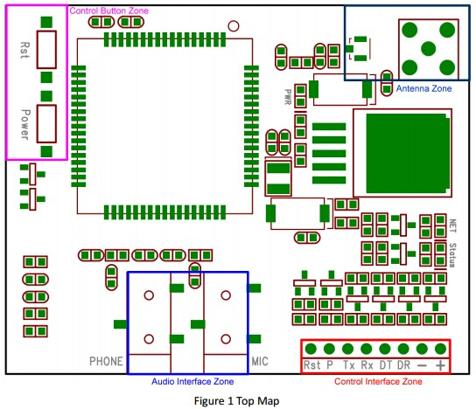
Fig 3.1.1 Hardware design of SIM900A

POWER REQUIREMENTS:
The board should be powered with an external power supply that can provide current between 700mA and 1000mA. Powering an Arduino and the GSM shield from a USB connection is not recommended, as USB cannot provide the required current when the modem is in heavy use. So instead we have to use 12V adapter. The modem can pull up to 2A of current at peak usage, which can occur during data transmission.

ON BOARD INDICATORS:
The shield contains a number of status LEDS:
NET: This LED blinks when the modem is communicating with the radio network. ON: It shows that the shield is getting power and is switched on.

NETWORK LED:
The Network LED indicates the various states of the GSM module i.e. POWER ON, NETWORK REGISTERATION and GPRS CONNECTIVITY. When the modem is powered up, this NETWORK LED will blink every second. After the Modem registers in the network (it takes 10-60 seconds), this LED will blink in step of 3 seconds at slow rate. At this stage we can start using the modem for our application. This shows that the modem is registered with the network.

AT COMMANDS FOR USING THE SHEILD
- CHECKING THE OPERATION AND CONNECTION OF GSM SHIELD:
AT Press ENTER This would print OK which signifies of working connection and operation of the GSM shield.
- MAKING A VOICE CALL: ATD+(country code)mobile number; Press ENTER.
- DISCONNECTING THE ACTIVE CALL: ATH Press ENTER.
- RECEIVING THE CALL: ATA Press ENTER.
- SENDING A MESSAGE: For sending SMS in text Mode: AT+CMGF=1 Press ENTER AT+CMGS=”mobile number” Press ENTER Once the AT commands is given’ >’ prompt will be displayed on the screen. Type the message to be sent via SMS. After this, Press CTRL+Z to send the SMS. If the SMS sending is successful, “OK” will be displayed along with the message number.
- RECEIVING A MESSAGE: For reading SMS in the text mode: AT+CMGF = 1 Press ENTER AT+CMGR = num. Number (num.) is the message index number stored in the SIM card. For new SMS, URC will be received on the screen as + CMTI: SM ‘num’. After this AT+CMGR=1 Press ENTER This displays the message on the screen along with sender details, number and timing too.

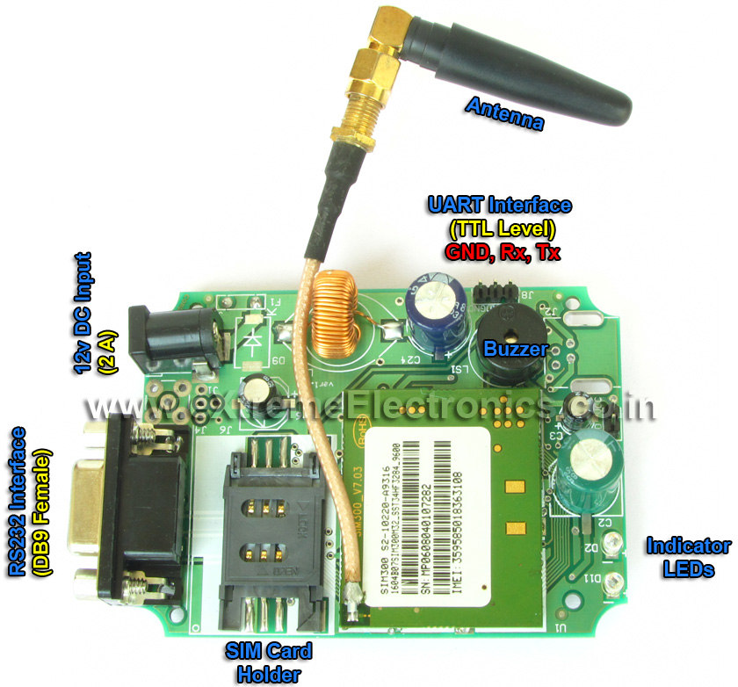
Fig 3.1.2 GSM SIM900A

ARDUINO BOARD
The Arduino Uno is a microcontroller board based on the ATmega328P. It has 14 digital input/output pins (of which 6 can be used as PWM outputs), 6 analog inputs, a 16 MHz quartz crystal, a USB connection, a power jack, an ICSP header and a reset button. It contains everything needed to support the microcontroller; simply connect it to a computer with a USB cable or power it with a AC-to-DC adapter or battery to get started.

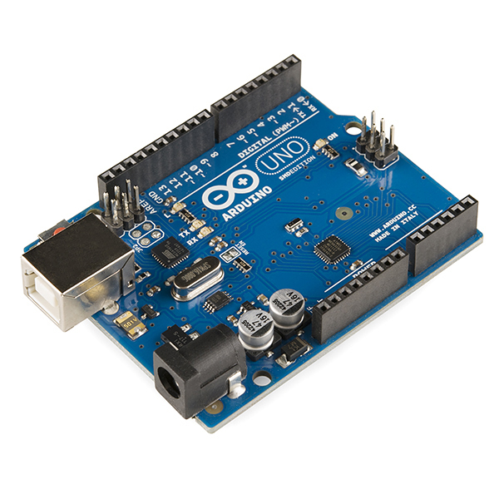
Fig 3.1.3 Arduino
The Uno has a number of facilities for communicating with a computer, another Uno board, or other microcontrollers. The ATmega328 provides UART TTL (5V) serial communication, which is available on digital pins 0 (RX) and 1 (TX). An ATmega16U2 on the board channels this serial communication over USB and appears as a virtual com port to software on the computer. The 16U2 firmware uses the standard USB COM drivers, and no external driver is needed. The Arduino Software (IDE) includes a serial monitor which allows simple textual data to be sent to and from the board. The RX and TX LEDs on the board will flash when data is being transmitted via the USB-to-serial chip and USB connection to the computer (but not for serial communication on pins 0 and 1).
Input and Output
Each of the 14 digital pins on the Uno can be used as an input or output, using pinMode(),digitalWrite(), and digitalRead() functions. They operate at 5 volts. Each pin can provide or receive 20 mA as recommended operating condition and has an internal pull-up resistor (disconnected by default) of 20-50k ohm. A maximum of 40mA is the value that must not be exceeded on any I/O pin to avoid permanent damage to the microcontroller.
Table 3.1.2 Specifications of Arduino Uno.
Microcontroller | ATmega328P
Operating Voltage | 5V
Input Voltage (recommended) | 7-12V
Input Voltage (limit) | 6-20V
Digital I/O Pins | 14 (of which 6 provide PWM output)
PWM Digital I/O Pins | 6
Analog Input Pins | 6
DC Current per I/O Pin | 20 mA
DC Current for 3.3V Pin | 50 mA
Flash Memory | 32 KB (ATmega328P)  of which 0.5 KB used by bootloader
SRAM | 2 KB (ATmega328P)
EEPROM | 1 KB (ATmega328P)
Clock Speed | 16 MHz
Length | 68.6 mm

In addition, some pins have specialized functions:
- Serial: 0 (RX) and 1 (TX). Used to receive (RX) and transmit (TX) TTL serial data. These pins are connected to the corresponding pins of the ATmega8U2 USB-to-TTL Serial chip.
- External Interrupts: 2 and 3. These pins can be configured to trigger an interrupt on a low value, a rising or falling edge, or a change in value. See the attachInterrupt() function for details.
- PWM: 3, 5, 6, 9, 10, and 11. Provide 8-bit PWM output with the analogWrite() function.
- SPI: 10 (SS), 11 (MOSI), 12 (MISO), 13 (SCK). These pins support SPI communication using the SPI library.
- LED: 13. There is a built-in LED driven by digital pin 13. When the pin is HIGH value, the LED is on, when the pin is LOW, it's off.
- TWI: A4 or SDA pin and A5 or SCL pin. Support TWI communication using the Wire library.
The Uno has 6 analog inputs, labelled A0 through A5, each of which provide 10 bits of resolution (i.e. 1024 different values). By default they measure from ground to 5 volts, though is it possible to change the upper end of their range using the AREF pin and the analog Reference() function.
There are a couple of other pins on the board:
- AREF. Reference voltage for the analog inputs. Used with analogReference().
- Reset. Bring this line LOW to reset the microcontroller. Typically used to add a reset button to shields which block the one on the board.
Power
The Uno board can be powered via the USB connection or with an external power supply. The power source is selected automatically.
External (non-USB) power can come either from an AC-to-DC adapter (wall-wart) or battery. The adapter can be connected by plugging a 2.1mm center-positive plug into the board's power jack. Leads from a battery can be inserted in the GND and Vin pin headers of the POWER connector.
The board can operate on an external supply from 6 to 20 volts. If supplied with less than 7V, however, the 5V pin may supply less than five volts and the board may become unstable. If using more than 12V, the voltage regulator may overheat and damage the board. The recommended range is 7 to 12 volts.
The power pins are as follows:
- Vin. The input voltage to the Uno board when it's using an external power source (as opposed to 5 volts from the USB connection or other regulated power source). You can supply voltage through this pin, or, if supplying voltage via the power jack, access it through this pin.
- 5V.This pin outputs a regulated 5V from the regulator on the board. The board can be supplied with power either from the DC power jack (7 - 12V), the USB connector (5V), or the VIN pin of the board (7-12V). Supplying voltage via the 5V or 3.3V pins bypasses the regulator, and can damage your board. We don't advise it.
- 3V3. A 3.3 volt supply generated by the on-board regulator. Maximum current draw is 50 mA.
- GND. Ground pins.
- IOREF. This pin on the Uno board provides the voltage reference with which the microcontroller operates. A properly configured shield can read the IOREF pin voltage and select the appropriate power source or enable voltage translators on the outputs to work with the 5V or 3.3V.

Communication
The Uno has a number of facilities for communicating with a computer, another Uno board, or other microcontrollers. The ATmega328 provides UART TTL (5V) serial communication, which is available on digital pins 0 (RX) and 1 (TX). An ATmega16U2 on the board channels this serial communication over USB and appears as a virtual com port to software on the computer. The 16U2 firmware uses the standard USB COM drivers, and no external driver is needed. The Arduino Software (IDE) includes a serial monitor which allows simple textual data to be sent to and from the board. The RX and TX LEDs on the board will flash when data is being transmitted via the USB-to-serial chip and USB connection to the computer (but not for serial communication on pins 0 and 1).
A SoftwareSerial library allows serial communication on any of the Uno's digital pins.
The ATmega328 also supports I2C (TWI) and SPI communication. The Arduino Software (IDE) includes a Wire library to simplify use of the I2C bus.

Automatic (Software) Reset
Rather than requiring a physical press of the reset button before an upload, the Uno board is designed in a way that allows it to be reset by software running on a connected computer. One of the hardware flow control lines (DTR) of the ATmega8U2/16U2 is connected to the reset line of the ATmega328 via a 100 nanofarad capacitor. When this line is asserted (taken low), the reset line drops long enough to reset the chip. The Arduino Software (IDE) uses this capability to allow you to upload code by simply pressing the upload button in the interface toolbar. This means that the bootloader can have a shorter timeout, as the lowering of DTR can be well-coordinated with the start of the upload.
This setup has other implications. When the Uno is connected to either a computer running Mac OS X or Linux, it resets each time a connection is made to it from software (via USB). For the following half-second or so, the bootloader is running on the Uno. While it is programmed to ignore malformed data (i.e. anything besides an upload of new code), it will intercept the first few bytes of data sent to the board after a connection is opened. If a sketch running on the board receives one-time configuration or other data when it first starts, make sure that the software with which it communicates waits a second after opening the connection and before sending this data.
The Uno board contains a trace that can be cut to disable the auto-reset. The pads on either side of the trace can be soldered together to re-enable it. It's labeled "RESET-EN". You may also be able to disable the auto-reset by connecting a 110 ohm resistor from 5V to the reset line.

Interfacing GSM shield with ARDUINO UNO
• First we connect our Arduino Uno to the Computer or Laptop to see which COM port will be used to burn the program from the computer or laptop. This also provides power to the Arduino Uno
• Next we supply power to the GSM shield (supply only 12V to the GSM shield from the power jack using the adapter) which is going to be used for our program
• For GSM programs, only 2 pins, RX and TX are to be used mainly. So we require only these two pins of the Arduino Uno. These pins are pins 0 and 1 of the Arduino Uno
• Next burn the required program in The Arduino Uno using the software
• Then connect the GSM shield to Arduino such that RX, TX of the shield is connected to the TX, RX of the Arduino Uno.
• Your interfacing is completed.

RELAY MODULE
This is a 5V 2-Channel Relay interface board, Be able to control various appliances, and other equipments with large current. It can be controlled directly by Micro-controller (Arduino , 8051, AVR, PIC, DSP, ARM, ARM, MSP430, TTL logic) .
Features:
- 5V 2-Channel Relay interface board, and each one needs 15-20mA Driver Current
- Equipped with high-current relay, AC250V 10A ; DC30V 10A
- Standard interface that can be controlled directly by microcontroller (Arduino , 8051, AVR, PIC, DSP, ARM, ARM, MSP430, TTL logic) .
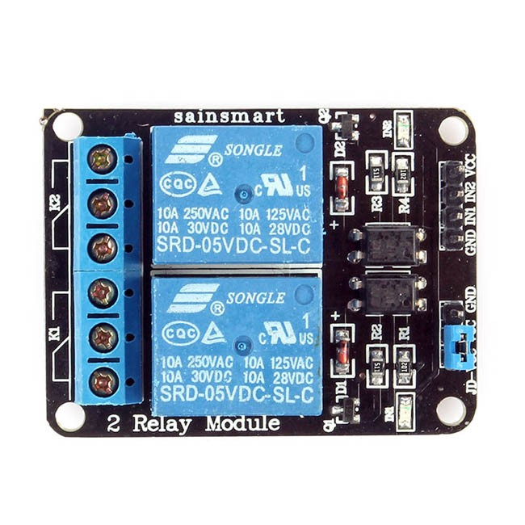
Fig 3.1.4 Relay Module

Light Emitting Diodes:
Light-emitting diodes are elements for light signalization in electronics. They are manufactured in different shapes, colors and sizes. For their low price, low consumption and simple use, they have almost completely pushed aside other light sources, bulbs at first place. They perform similar to common diodes with the difference that they emit light when current flows through them.
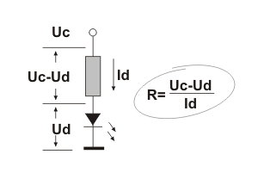
It is important to know that each diode will be immediately destroyed unless its current is limited. This means that a conductor must be connected in parallel to a diode. In order to correctly determine the value of this conductor, it is necessary to know diode’s voltage drop in forward direction, which depends on what material a diode is made of and what colour it is. As seen, there are three main types of LEDs. Standard ones get full brightness at current of 20mA. Low Current diodes get full brightness at ten times lower current while Super Bright diodes produce more intensive light than Standard ones.
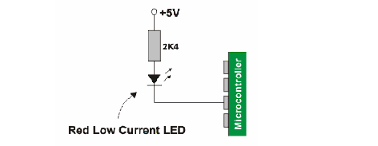
Since the 8051 microcontrollers can provide only low input current and since their pins are configured as outputs when voltage level on them is equal to 0, direct connecting to LEDs is carried out as it is shown on figure (Low current LED, cathode is connected to output pin).

LED Interfacing with 8051:
Microcontroller port pins cannot drive these LEDs as these require high currents to switch on. Thus the positive terminal of LED is directly connected to Vcc, power supply and the negative terminal is connected to port pin through a current limiting resistor.
This current limiting resistor is connected to protect the port pins from sudden flow of high currents from the power supply.

Thus in order to glow the LED, first there should be a current flow through the LED. In order to have a current flow, a voltage difference should exist between the LED terminals. To ensure the voltage difference between the terminals and as the positive terminal of LED is connected to power supply Vcc, the negative terminal has to be connected to ground. Thus this ground value is provided by the microcontroller port pin. This can be achieved by writing an instruction “CLR P1.0”. With this, the port pin P1.0 is initialized to zero and thus now a voltage difference is established between the LED terminals and accordingly, current flows and therefore the LED glows. LED and switches can be connected to any one of the four port pins.

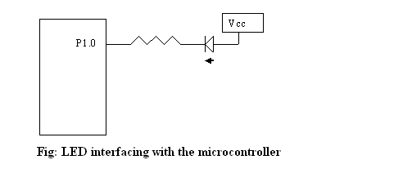

2.3 Software Requirements
The basic software requirements for developing our system are Arduino IDE which is used for developing the code and we also used Android Studio for designing the interface which is used for sending the SMS automatically on checking the radio buttons.
ARDUINO IDE
The Arduino Integrated Development Environment - or Arduino Software (IDE) - contains a text editor for writing code, a message area, a text console, a toolbar with buttons for common functions and a series of menus. It connects to the Arduino and Genuino hardware to upload programs and communicate with them.
Sketchbook
The Arduino Software (IDE) uses the concept of a sketchbook: a standard place to store your programs (or sketches). The sketches in your sketchbook can be opened from the File > Sketchbook menu or from the Open button on the toolbar. The first time you run the Arduino software, it will automatically create a directory for your sketchbook. You can view or change the location of the sketchbook location from with the Preferences dialog.

Tabs, Multiple Files, and Compilation
Allows you to manage sketches with more than one file (each of which appears in its own tab). These can be normal Arduino code files (no visible extension), C files (.c extension), C++ files (.cpp), or header files (.h).

Uploading
Before uploading your sketch, you need to select the correct items from the Tools > Board and Tools > Port menus. On the Mac, the serial port is probably something like /dev/tty.usbmodem241 (for an Uno or Mega2560 or Leonardo) or /dev/tty.usbserial-1B1 (for a Duemilanove or earlier USB board), or/dev/tty.USA19QW1b1P1.1 (for a serial board connected with a Keyspan USB-to-Serial adapter). On Windows, it's probably COM1 or COM2 (for a serial board) or COM4, COM5, COM7, or higher (for a USB board) - to find out, you look for USB serial device in the ports section of the Windows Device Manager. On Linux, it should be /dev/ttyACMx ,/dev/ttyUSBx or similar. Once you've selected the correct serial port and board, press the upload button in the toolbar or select the Upload item from the File menu. Current Arduino boards will reset automatically and begin the upload. With older boards (pre-Diecimila) that lack auto-reset, you'll need to press the reset button on the board just before starting the upload. On most boards, you'll see the RX and TX LEDs blink as the sketch is uploaded. The Arduino Software (IDE) will display a message when the upload is complete, or show an error.
When you upload a sketch, you're using the Arduino bootloader, a small program that has been loaded on to the microcontroller on your board. It allows you to upload code without using any additional hardware. The bootloader is active for a few seconds when the board resets; then it starts whichever sketch was most recently uploaded to the microcontroller. The bootloader will blink the on-board (pin 13) LED when it starts (i.e. when the board resets).
Libraries
Libraries provide extra functionality for use in sketches, e.g. working with hardware or manipulating data. To use a library in a sketch, select it from the Sketch > Import Library menu. This will insert one or more #include statements at the top of the sketch and compile the library with your sketch. Because libraries are uploaded to the board with your sketch, they increase the amount of space it takes up. If a sketch no longer needs a library, simply delete its #include statements from the top of your code.
Third-Party Hardware
Support for third-party hardware can be added to the hardware directory of your sketchbook directory. Platforms installed there may include board definitions (which appear in the board menu), core libraries, boot loaders, and programmer definitions. To install, create the hardware directory, then unzip the third-party platform into its own sub-directory.
Serial Monitor
Displays serial data being sent from the Arduino or Genuino board (USB or serial board). To send data to the board, enter text and click on the "send" button or press enter. Choose the baud rate from the drop-down that matches the rate passed to Serial.begin in your sketch. Note that on Windows, Mac or Linux, the Arduino or Genuino board will reset (rerun your sketch execution to the beginning) when you connect with the serial monitor.

ANDROID STUDIO
Android Studio is the official IDE for Android app development, based on IntelliJ IDEA. On top of IntelliJ's powerful code editor and developer tools, Android Studio offers even more features that enhance your productivity when building Android apps, such as:
- A flexible Gradle-based build system
- Build variants and multiple APK file generation
- Code templates to help you build common app features
- A rich layout editor with support for drag and drop theme editing
- Lint tools to catch performance, usability, version compatibility, and other problems
- Code shrinking with ProGuard and resource shrinking with Gradle
- Built-in support for Google Cloud Platform, making it easy to integrate Google Cloud Messaging and App Engine

Project Structure
Each project in Android Studio contains one or more modules with source code files and resource files. Different types of modules include:
- Android app modules
- Test modules
- Library modules
- App Engine modules
By default, Android Studio displays your project files in the Android project view. This view is organized by modules to provide quick access to the key source files of your project.
All the build files are visible at the top level under Gradle Scripts and each app module contains the following three elements:
- manifests: Manifest files.
- java: Source code files.
- res: Resource files.
The Android project structure on disk differs from this flattened representation. To see the actual file structure of the project, select Project from the Project drop-down.
You can also customize the view of the project files to focus on specific aspects of your app development. For example, selecting the Problems view of your project displays links to the source files containing any recognized coding and syntax errors, such as missing an XML element closing tag in a layout file.
Gradle Build System
Android Studio uses Gradle as the foundation of the build system, with more Android-specific capabilities provided by the Android Plugin for Gradle. This build system runs as an integrated tool from the Android Studio menu and independently from the command line. You can use the features of the build system to:
- Customize, configure, and extend the build process.
- Create multiple APKs for your app with different features using the same project and modules.
- Reuse code and resources across source sets.
The flexibility of Gradle enables you to achieve all of this without modifying your app's core source files.
Android Studio provides graphical tools for creating and managing Android projects, which contain everything that define your Android apps, from app source code to build configurations and test code. Each project contains one or more different types of modules, such as application modules, library modules, and test modules.

Creating An Android Project
Creating an android project involves various steps. They are:
1.create a New Project.
2.Select Form Factors and API Levels
3.Add an Activity
4.configure your activity
5.Develop your App.

AVD Manager
To effectively test your app, you should create an AVD that models each device type that your app is designed to support. For example, we recommend that you create an AVD for each API level that's equal to and higher than the minimum version you've specified in your manifest <uses-sdk> tag.
An AVD contains a hardware profile, system image, skin, and other properties.
The hardware profile defines the characteristics of a device as shipped from the factory. The AVD Manager comes preloaded with certain hardware profiles, such as Nexus phone devices, and you can define and import hardware profiles as needed. You can override some of the settings in your AVD, if needed.
The AVD Manager helps you choose a system image for your AVD by providing recommendations. It also lets you download system images, some with add-on libraries, like Google APIs, which your app might require. x86 system images run the fastest in the emulator. Android Wear and Android TV devices tend to run best (and have the largest installed base) on recent releases, while users of Android phones and tablets tend to use slightly older releases, as shown in theAPI level dashboards.
An emulator skin specifies the appearance of a device. The AVD Manager provides some predefined skins. You can also define your own, or use skins provided by third parties.

Android Emulator
The Android Emulator is fast, powerful, and feature-rich. It can transfer information faster than using a connected hardware device, speeding up the development process. The multi-core feature lets the emulator take advantage of multiple core processors on your development computer to improve emulator performance even more.
You can launch an app on the emulator when you run your project, or you can drag an APK file onto the emulator to install it. As with a hardware device, after you install an app on a virual device, it remains until you uninstall or replace it. If needed, you can test how multiple apps, such as your own or system apps, work with each other.
You interact with the emulator just as you would with a hardware device, but using your mouse and keyboard, and emulator buttons and controls. The emulator supports virtual hardware buttons and touchscreens, including two-finger operations, as well as directional pads (D-pads), trackballs, wheels, and various sensors. You can dynamically resize the emulator window as needed, zoom in and out, change the orientation, and even take a screenshot.
When your app is running on the emulator, it can use the services of the Android platform to invoke other apps, access the network, play audio and video, accept audio input, store and retrieve data, notify the user, and render graphical transitions and themes. The emulator has controls that let you easily send incoming phone calls and text messages, specify the location of the device, simulate fingerprint scans, specify network speed and status, and simulate battery properties. The emulator can simulate an SD card and internal data storage; you can drag a file, such as a graphics or data file, onto the emulator to store it.

3.SYSTEM DESIGN
This chapter will let us know complete details about the specific design of the entire system in the form of UML Diagrams.
UML Diagrams
Class Diagram
The class diagram is a static diagram. It represents the static view of an application. Class diagram is not only usedfor visualizing, describing and documenting different aspects of a system but also for constructing executable code of the software application.The class diagram describes the attributes and operations of a class and also the constraints imposed on the system. The class diagrams are widely used in the modelling of object oriented systems because they are the only UML diagrams which can be mapped directly with object oriented languages.The class diagram shows a collection of classes, interfaces, associations, collaborations and constraints. It is also known as a structural diagram.

Purpose:
The purpose of the class diagram is to model the static view of an application. The class diagrams are the only diagrams which can be directly mapped with object oriented languages and thus widely used at the time of construction.The UML diagrams like activity diagram, sequence diagram can only give the sequence flow of the application but class diagram is a bit different. So it is the most popular UML diagram in the coder community.
So the purpose of the class diagram can be summarized as:

- Analysis and design of the static view of an application.
- Describe responsibilities of a system.
- Base for component and deployment diagrams.
- Forward and reverse engineering.

Class diagrams are the most popular UML diagrams used for construction of software applications. So it is very important to learn the drawing procedure of class diagram.
Class diagrams have lot of properties to consider while drawing but here the diagram will be considered from a top level view.Class diagram is basically a graphical representation of the static view of the system and represents different aspects of the application. So a collection of class diagrams represent the whole system.
The following points should be remembered while drawing a class diagram:

- The name of the class diagram should be meaningful to describe the aspect of the system.
- Each element and their relationships should be identified in advance.
- Responsibility (attributes and methods) of each class should be clearly identified.
- For each class minimum number of properties should be specified. Because unnecessary properties will make the diagram complicated.
- Use notes when ever required to describe some aspect of the diagram. Because at the end of the drawing it should be understandable to the developer/coder.
- Finally, before making the final version, the diagram should be drawn on plain paper and rework as many imes as possible to make it correct.

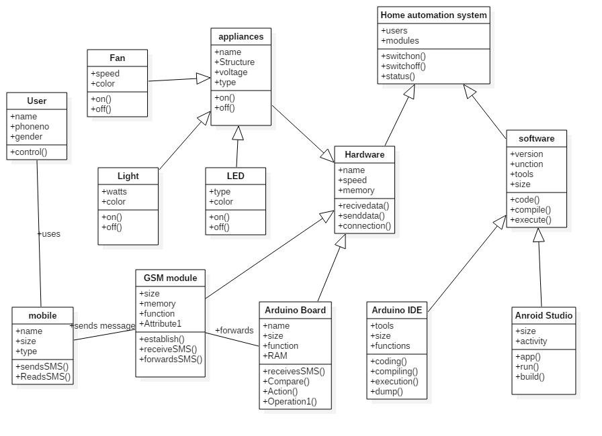
Fig 4.1 Class Diagram
Above diagram is the class Diagram for our Project. It shows us all the classes involved in our system.The Main class is the HAS(Home Automation System) and Hardware and Software are the subclasses under HAS. Inherently, each of these subclasses have few more subclasses each performing its own function.

UseCase Diagram
Use case diagrams are used to gather the requirements of a system including internal and external influences. These requirements are mostly design requirements. So when a system is analyzed to gather its functionalities use cases are prepared and actors are identified.
Now when the initial task is complete use case diagrams are modelled to present the outside view.
So in brief, the purposes of use case diagrams can be as follows:
• Used to gather requirements of a system.
• Used to get an outside view of a system.
• Identify external and internal factors influencing the system.
• Show the interacting among the requirements are actors.

Use case diagrams are considered for high level requirement analysis of a system. So when the requirements of a system are analyzed the functionalities are captured in use cases.So we can say that uses cases are nothing but the system functionalities written in an organized manner. Now the second things which are relevant to the use cases are the actors. Actors can be defined as something that interacts with the system.
The actors can be human user, some internal applications or may be some external applications. So in a brief when we are planning to draw an use case diagram we should have the following items identified.
• Functionalities to be represented as an use case
• Actors
• Relationships among the use cases and actors.

Use case diagrams are drawn to capture the functional requirements of a system. So after identifying the above items we have to follow the following guidelines to draw an efficient use case diagram.
• The name of a use case is very important. So the name should be chosen in such a way so that it can identify the functionalities performed.
• Give a suitable name for actors.
• Show relationships and dependencies clearly in the diagram.
• Do not try to include all types of relationships. Because the main purpose of the diagram is to identify requirements.
• Use note when ever required to clarify some important points.
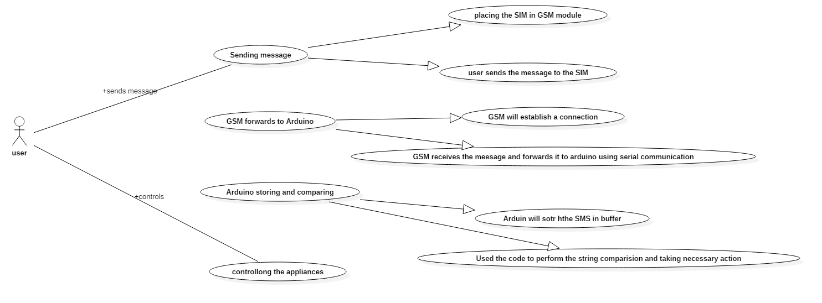
Fig UseCase Diagram

This is the UseCase diagram of the system.It shows us the actors and various usecases in the system. This diagram specifies what function is performed by who.
Sequence Diagram
The purpose of interaction diagrams is to visualize the interactive behaviour of the system. Now visualizing interaction is a difficult task. So the solution is to use different types of models to capture the different aspects of the interaction.That is why sequence and collaboration diagrams are used to capture dynamic nature but from a different angle.
So the purpose of interaction diagram can be described as:
• To capture dynamic behaviour of a system.
• To describe the message flow in the system.
• To describe structural organization of the objects.
• To describe interaction among objects.

We have two types of interaction diagrams in UML. One is sequence diagram and the other is a collaboration diagram. The sequence diagram captures the time sequence of message flow from one object to another and the collaboration diagram describes the organization of objects in a system taking part in the message flow.
So the following things are to identified clearly before drawing the interaction diagram:
• Objects taking part in the interaction.
• Message flows among the objects.
• The sequence in which the messages are flowing.
• Object organization.
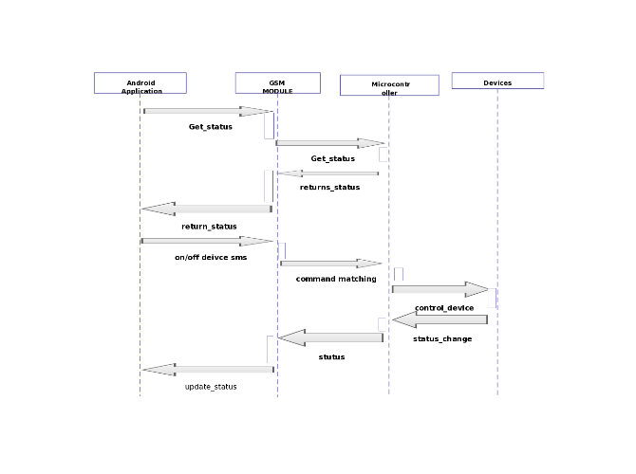
The sequence diagram is having four objects (Android App, GSM Module, Microcontroller and Devices).
The above diagram has shown the message sequence for Controlling a device object and the same can be used in case . Now it is important to understand the time sequence of message flows. The message flow is nothing but a method call of an object.
The first call is Get_Status() which is a method of Android App object. This method is again called by GSM module and send it to Microcontroller. This object will send back the status of the system to the android app. The next call is control() function which will ON or OFF the required device. Once this action is performed the status of the system is again updated.

4.IMPLEMENTATION
This chapter will give us the actual description of the above mentioned modules in the design part. It also explains the specific system architecture.
Architecture of the System

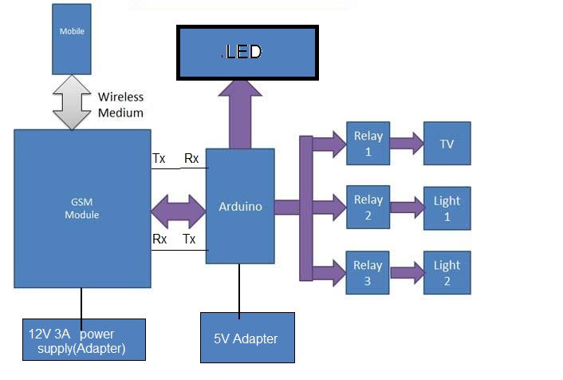
The above presented diagram gives us the clear picture about the specific architecture which is used for the system. As we see there are all the modules presented which are required by our system. The first is the Mobile phone which we will use for sending the messages. Next is the GSM module which establishes a wireless connection with the mobile device. This module is responsible for receiving the messages and sending them to other devices. This devices is also connected to the microcontroller unit which is the Arduino Board in our system. There is a serial communication established between GSM module and Arduino Board which is obtained by connecting the Tx pin of arduino to Rx pin of GSM and Tx pin of GSM to Rx pin of arduino. There are also external adapters provided for each modules based on their operating voltage. Once the GSM module receives the message it forwards it automatically to the arduino through the serial communication established before. Arduino board makes use of the program which is developed using arduino IDE and dumped in to the arduino Board. This code will compare the SMS received with the predefined message and takes the required action by sending the signal directly to devices or the relay module.

Pseudo Code:
#include <SoftwareSerial.h>
#include <String.h>

SoftwareSerial mySerial(Rx, Tx);//creating a structure for serial communication.

void setup()
{
//this function is used to setup the configuration of the system.
//Using functions pins are activated.

pinMode(pin number, type);//to make pin as input or output

digitalWrite(pin number,low/high);//used to make pin as high or low

Serial.begin(9600);

while (!Serial) {

; // wait for serial port to connect. Needed for native USB port only

}

mySerial.begin(9600);

//Using AT commands we need to make GSM module to enter in to the required mode.

}

void loop()
{

// Variable declerations.

if(mySerial.available() != 0)
{

//if there is data in the buffer
while( mySerial.available() > 0)

//read the data in to an array.

if (strstr(arrayvalue, command) != NULL)
{
//perform the action by making the required pin as high or low.
}

}

In the above code we have to create a structure by giving it a name and by defining the Tx and Rx pins of the arduino board. After that in the loop( ) function we should check if there is any data available in the buffer using available( ) function. If there is any data in the buffer we should read that data using read( ) function and store it in a string or an array. Using the string comparison function compare the string with a given command and perform the required action if the string matches.

5 RESULTS AND DISCUSSIONS
The following table will give the clear picture of various commands that we used in our project and actions performed by them.
COMMAND RECEIVED | ACTION PERFORMED
FANON  FANOFF  LIGHTON  LIGHTOFF  LEDON  LEDOFF  ALLON  ALLOFF | Switch on the fan  Switch off the fan  Turns On the light  Turns Off the light  LED is turned On  LED is turned Off  Turns On all the appliances  Turns Off all the appliances

Table 5.1 Commands and their Action

Testing Analysis:
After repeated iterations we observed that the system can even work by sending multiple commands in a single SMS. This is because of the strstr() function we used in developing the code. This function checks for the substring and if matches then the required action is taken.
Test Cases:
All the possible results that occur can be shown by considering different
test cases. Here are the test cases conducted and the possible results.

Test Case 1:Sending a single message at a time

When we send a single message the possible conditions are:

Condition 1:LIGHT ON
When we send this message the system takes the input and shows the result by turning ON the light .As the light is an A.C. device, Arduino board output pin is connected to the relay module. When this pin is high the connection will be closed and the light turn on.

Condition 2:LIGHT OFF
When we send this message the system takes the input and shows the result by turning OFF the light .As the light is an A.C. device, Arduino board output pin is connected to the relay module. When this pin is low the connection will be of open type and the light turn off.

Condition 3:LED ON
When we send this message the system takes the input and shows the result by turning ON the LED .As the LED is an D.C. device, the active wire of LED is connected to the output pin of arduino and the neutral wire of LED is connected to the ground of arduino. On receiving this message the pin becomes high and LED turn on.

Condition 4:LED OFF
When we send this message the system takes the input and shows the result by turning OFF the LED .As the LED is an D.C. device, the active wire of LED is connected to the output pin of arduino and the neutral wire of LED is connected to the ground of arduino. On receiving this message the pin becomes low and LED turns off.

Condition 5:FAN ON
When we send this message the system takes the input and shows the result by turning ON the fan .As the fan is an A.C. device, Arduino board output pin is connected to the relay module. On receiving this message the pin becomes high and the relay connection will be closed and the Fan turn on.

Condition 6:FAN OFF
When we send this message the system takes the input and shows the result by turning OFF the fan .As the fan is an A.C. device, Arduino board output pin is connected to the relay module. On receiving this message the pin becomes low and the relay connection will become as open and the Fan turns off.

Condition 7:ALL ON
On receiving this message the system will make all the output pins as high there by turning ON all the devices connected to the system.

Condition 8:ALL OFF
On receiving this message the system will make all the output pins as low there by turning OFF all the devices connected to the system.

Test case 2:
Sending single message with some other characters as prefix and suffixes.
If we send the message by attaching some prefixes or suffixes or any other characters the system will work irrespective of the received command.
For example if we send the message as " 123FANONabc:) ".when the system receives this message it will turn on the fan as the function we are using for comparison will check for the availability of the given substring in the received message. So the system works fine even if we give any String in the above mentioned format.

Test Case 3:
Sending multiple commands in a single SMS.
If we send multiple commands in a single SMS the system will read the entire message and it will perform the actions on all the devices mentioned.
For instance if we send the SMS as "FANON LIGHTOFF" the system will read the entire string and it will turns on the fan and switches off the light simultaneously.

Test Case 4:
Sending the message in lower case and combination of lower and upper cases
If we send the message in the lower cases or the combination of both lower and upper cases, the system will not give us the desired results. This is because we have defined a predefined command in our code for comparison. As the function uses the ASCII numbers of each character the ASCII values of the lower and upper case of the same character will be different.
For example, on giving the message as "lgiht ON" the system will not turn ON the light as the keyword light is in the lower cases.

Compatibility:
The modules we used for developing the system can be replaced by various versions of those modules.GSM modules of two types can be used in developing our system.SIM300 and SIM900A can be used as the GSM modem.
We used the basic version of the arduino i.e Aruino UNO in our project. we can use all the other versions of arduino boards. We can also use any of the microcontrollers available in the market.

6.CONCLUSION AND FUTURE ENHANCEMENTS
Thus Our project is being developed for solving the problems of controlling the household appliances manually. By using single SMS one can control their home appliances from anywhere in the world. This will reduce the physical work of people and it can relieve their tension. This project can be extended all other things like Kitchen appliances, Automobile industry and for Irrigation purpose etc.
In future, we can enhance the project by embedding small hardware that checks the signals in the wires and gives feedback to the user. This could be used for knowing the current status of the system.
In addition to that we can also develop a GUI based application having networking capabilities that facilitates with GUI controls so that instead of typing the Message manually by the user, he can use the controls for Switching ON and OFF the home appliance.

References
- A. W. Ahmad, N. Jan, S. Iqbal, and C. Lee, "Implementation of Zig Bee-GSM based Home Security Monitoring and Remote Control system," in Proc. 2011 IEEE 54th International Midwest Symposium on Circuits and Systems (MWSCAS), Seoul, pp. 1-4.
- G. Mingming, Shaoliangshan, Huixiaowei, and Sunqingwei, "The System of Wireless Smart House Based on GSM and Zig Bee," in Proc. 2010 International Conference on Intelligent Computation Technology and Automation (ICICTA), Changsha, pp. 1017-1020.
- Y. Zhai and X. Cheng, "Design of smart home remote monitoring system based on embedded system," in Proc. 2011 2nd International Conference on Computing, Control and Industrial Engineering (CCIE), Wuhan, pp. 41-44.
- H. El-Kamchouchi and A. El-Shafee, "Design and prototype implementation of SMS based home automation system", in Proc. 2012 IEEE International Conference on Electronics Design, Systems and Applications (ICEDSA), Kuala Lumpur, pp. 162-167.
- M. S. Khandare and A. Mahajan, "Mobile Monitoring System for Smart Home," in Proc. 2010 3rd International Conference on Emerging Trends in Engineering and Technology (ICETET), Goa, pp. 848-852.
- C. Felix and I. J. Raglend, "Home automation using GSM," in Proc. 2011 International Conference on Signal Processing, Communication, Computing and Networking Technologies (ICSCCN), Thuckafay, pp. 15-19.
- L. Wei, Y. Min, C. Liang Liang, and C. Ping, "The Design of Intelligent Household Control System Based on Internet and GSM," in Proc. 2011 Second International Conference on Networking and Distributed Computing (ICNDC), Beijing, pp. 254-256.
- L. Pu, "An Improved Short Message Security Protocol for Home Network," in Proc. 2009 International Conference on Future Computer and Communication (FCC '09), Wuhan, pp. 62-65.
- K. Gill, S. -H. Yang, F. Yao, and X. Lu. (2009). A zigbeebased home automation system. IEEE Transactions on Consumer Electronics, 55(2), pp. 422-430.
- B. S. Rao, S. D. V. Prasad, and R.M. Mohan, "A prototype for Home Automation using GSM technology," in Proc. 2010 International Conference on Power, Control and Embedded Systems (ICPCES), Allahabad, pp. 1-4.

Appendix
#include <SoftwareSerial.h>
#include <String.h>

SoftwareSerial mySerial(0, 1);

void setup()
{
pinMode(8, OUTPUT);
pinMode(9, OUTPUT);
pinMode(10, OUTPUT);
digitalWrite(8, LOW);
digitalWrite(9, LOW);
digitalWrite(10, LOW);
Serial.begin(9600);
while (!Serial) {
; // wait for serial port to connect. Needed for native USB port only
}
Serial.println("Starting...");
mySerial.begin(9600);
mySerial.println("AT");
delay(5000);
mySerial.println("AT+CNMI=1,2,0,0,0");
delay(5000);
}

void loop()
{
int x=0;
char response[200];
if(mySerial.available() != 0)
{
while( mySerial.available() > 0)
response[x++]=mySerial.read();
response[x]=0;
if (strstr(response, "LIGHTON") != NULL)
{
Serial.println("LIGHT ON");
digitalWrite(8, HIGH);
delay(5000);
}
if (strstr(response, "LIGHTOFF") != NULL)
{
Serial.println("LIGHT OFF");
digitalWrite(8, LOW);
delay(5000);
}
if (strstr(response, "LEDON") != NULL)
{
Serial.println("LED ON");
digitalWrite(9, HIGH);
delay(5000);
}
if (strstr(response, "LEDOFF") != NULL)
{
Serial.println("LED OFF");
digitalWrite(9, LOW);
delay(5000);
}
if (strstr(response, "FANON") != NULL)
{
Serial.println("FAN ON");
digitalWrite(10, HIGH);
delay(5000);
}
if (strstr(response, "FANOFF") != NULL)
{
Serial.println("FAN OFF");
digitalWrite(10, LOW);
delay(5000);
}
if (strstr(response, "ALLON") != NULL)
{
Serial.println("ALL ON");
digitalWrite(8, HIGH);
digitalWrite(9, HIGH);
digitalWrite(10, HIGH);
delay(5000);
}
if (strstr(response, "ALLOFF") != NULL)
{
Serial.println("ALL OFF");
digitalWrite(8, LOW);
digitalWrite(9, LOW);
digitalWrite(10, LOW);
delay(5000);
}
}
}

